**Amazon Prime Video Analytics Dashboard**

**Introduction:** In today's fast-paced digital landscape, streaming services like Amazon Prime Video face intense competition and must continually adapt to meet viewer demands while optimizing their content offerings. To stay ahead, Amazon Prime Video requires precise and actionable insights into viewer behavior, content performance, and subscription trends. The Amazon Prime Video Analytics Dashboard, developed using Microsoft Power BI, provides an effective solution to this challenge by offering a powerful and visually intuitive platform for tracking key metrics.

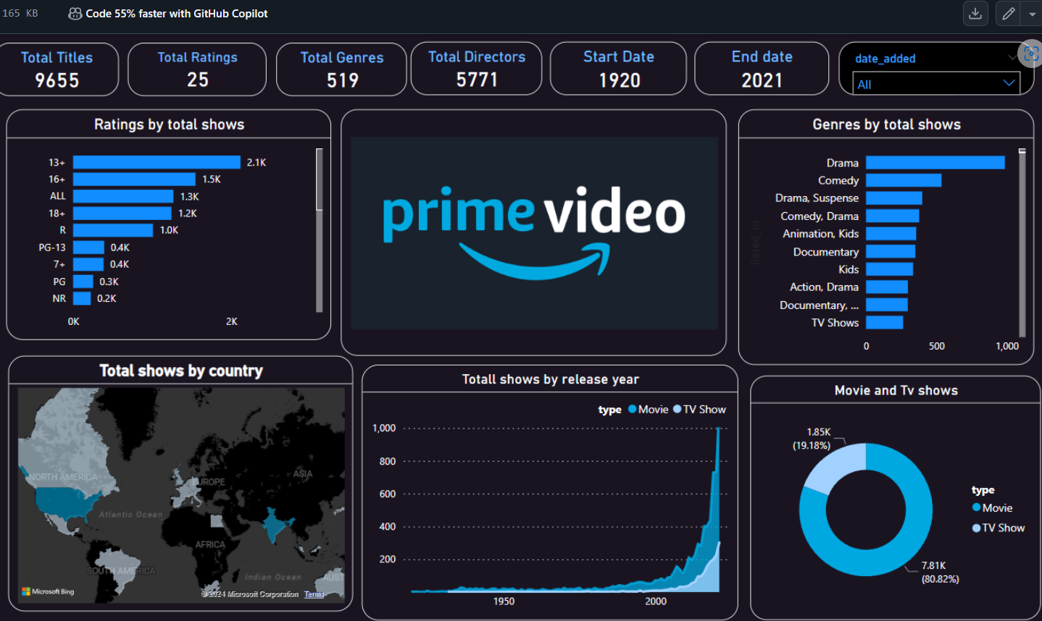

**Objectives:**

1. Provide Real-Time Viewer Engagement Analysis: The dashboard aims to offer users an up-to-date view of viewer engagement trends by visualizing data across different time periods and content categories.
2. Content Performance Analysis: By incorporating interactive visualizations, the project aims to help users compare content performance across various genres, allowing management to target areas where content is underperforming or excelling.
3. Analyze Viewer Behavior: Users can easily identify which content types and genres are driving the most engagement, enabling more informed content acquisition and marketing decisions.
4. Optimize Content Recommendations: The dashboard enables users to evaluate the effectiveness of content recommendations by visualizing viewer engagement data in   
     
   relation to recommended content, helping Amazon Prime Video optimize its recommendation algorithms.
5. Understand Viewer Preferences: By breaking down viewer engagement according to content categories, genres, and viewer demographics, the dashboard provides insights into viewer behavior patterns and preferences.

**Scope of Work:**   
The scope of this project encompasses the design, development, and implementation of a fully interactive dashboard for Amazon Prime Video. The dataset used in this project contains information on viewer engagement, content metadata, and subscription data.

**Features:**

1. Line Charts: Two line charts display daily and monthly viewer engagement trends by content category, providing a historical view of trends and allowing users to track the performance of different content types over time.
2. Heatmap Visualization: A dynamic heatmap illustrates viewer engagement data by content genre and time of day, helping to identify peak viewing hours and popular content genres.
3. Bar Charts: Three bar charts show viewer engagement by content type, genre, and viewer demographics. These charts are essential for identifying which content types and genres are driving the most engagement.
4. Donut Charts: Three donut charts break down viewer engagement by content category, genre, and viewer demographics. This feature allows users to quickly see how engagement is distributed across different content types and viewer segments.
5. Cards: The dashboard includes four KPI cards that display total viewers, engagement time, content views, and average watch time. These cards provide a snapshot of the most important metrics, ensuring that users can track performance at a glance.
6. Slicer Filters: An interactive slicer allows users to filter the data by content category, making it easier to focus on specific areas of the business.

**Methodology:**   
The methodology followed in the development of this dashboard is structured into several key phases:

1. Data Collection and Preparation: The first step involved gathering raw viewer engagement data from Amazon Prime Video's database. This data was then cleaned and preprocessed using Power Query in Power BI.
2. Data Modeling: Once the data was prepared, it was modeled in Power BI. Relationships between different tables (e.g., viewer engagement, content metadata, subscription data) were established to create a cohesive dataset that supports dynamic reporting and analysis.
3. Dashboard Design: The design process focused on creating a user-friendly interface with clear, concise visualizations. Color schemes were chosen to make the data more accessible, and charts were arranged in a logical sequence to guide users through the analysis.
4. Visualization and Interaction: Using Power BI's extensive visualization library, charts such as line charts, bar charts, and heatmaps were created. Interactive features like slicers and drill-down capabilities were added to enhance the user experience.
5. Testing and Validation: The final step involved testing the dashboard to ensure that it worked as expected. This included validating the accuracy of the data, ensuring that all interactive elements functioned correctly, and optimizing performance to ensure a smooth user experience.

**Tools and Technologies:**   
Microsoft Power BI: Power BI is the primary tool used to create this dashboard, due to its ability to handle large datasets and provide interactive, real-time visualizations. Power Query: Power Query was used for data transformation and cleansing. Data Sources: Viewer engagement data was sourced from Amazon Prime Video's database. Additional Tools: Excel may have been used for preliminary data analysis and exploration before importing the data into Power BI.

**Conclusion:** The Amazon Prime Video Analytics Dashboard project successfully demonstrates the power of data visualization in streaming analytics. By bringing together data on viewer engagement, content performance, and subscription trends, the dashboard serves as a comprehensive tool for Amazon Prime Video to make informed decisions. Through its user-friendly design and interactive features, the dashboard allows users to uncover trends, monitor performance, and identify opportunities for growth. As a result, Amazon Prime Video can optimize its content offerings, streamline